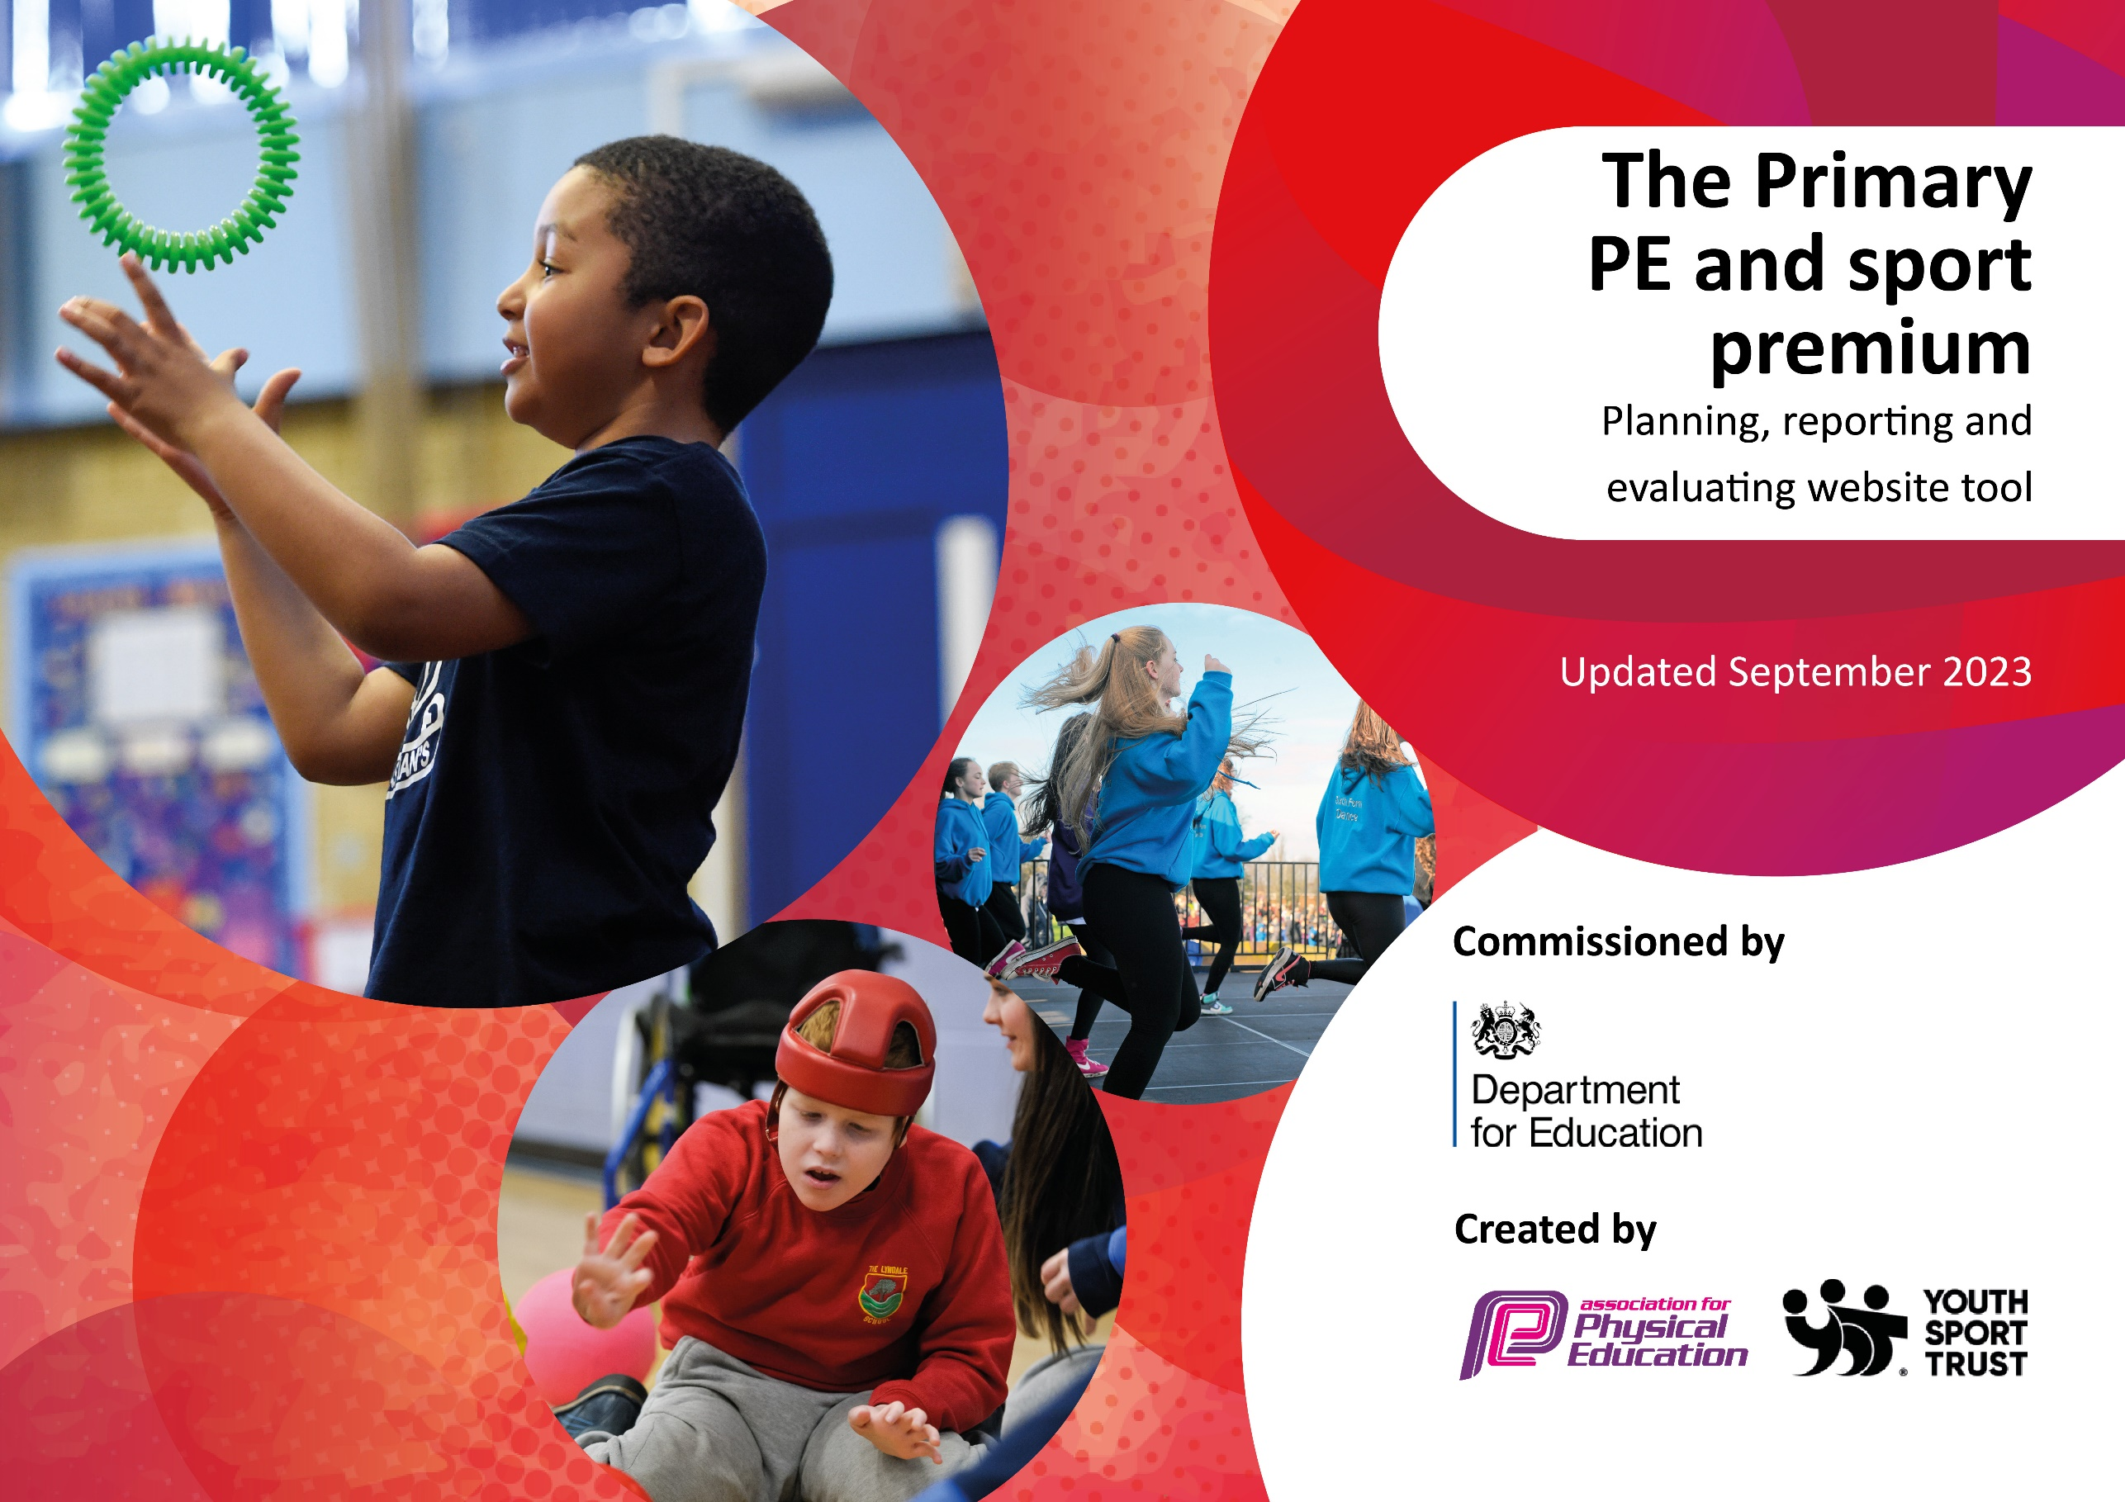

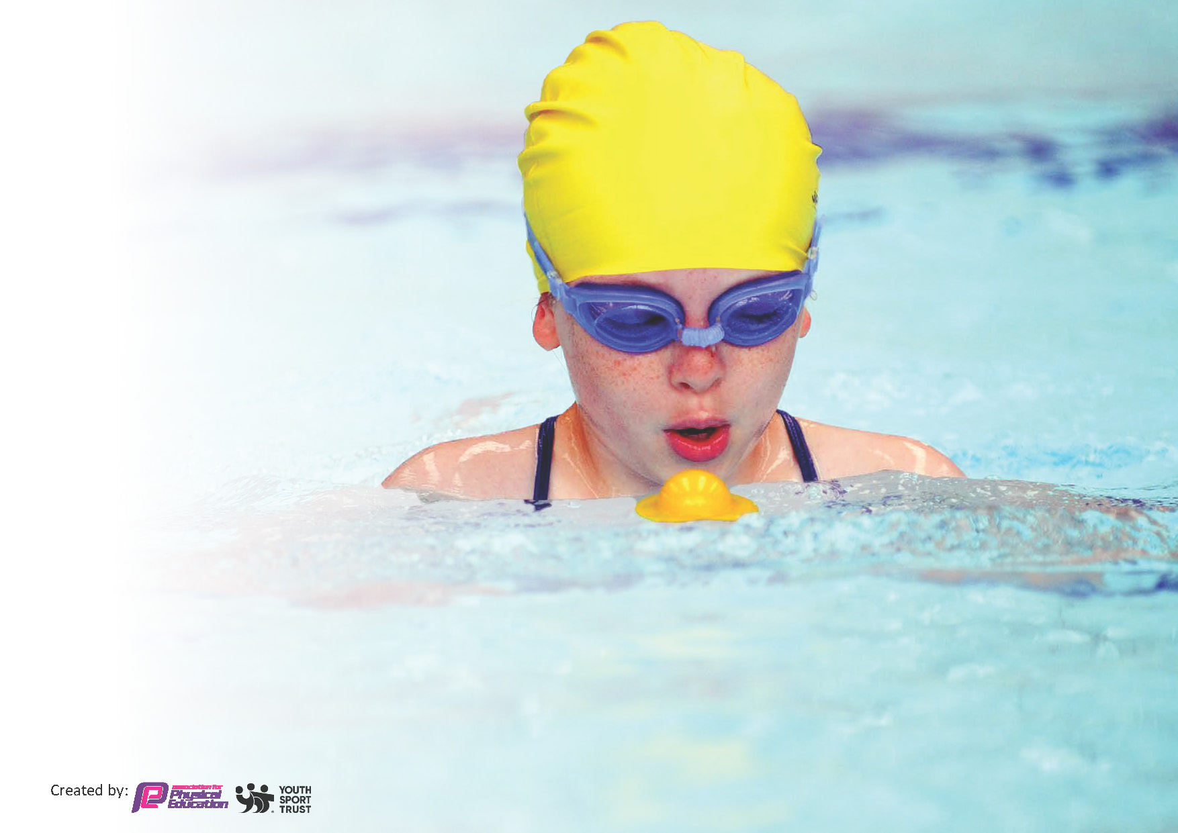
This template can be used for multiple purposes:
by:
- It enables schools to effectively plan their use of the Primary PE and sport premium
- It helps schools to meet the requirements (as set out in guidance) to publish information on their Primary PE and sport premium
- It will be an effective document to support Ofsted inspections enabling schools to evidence progress in Physical Education (PE) and evidence swimming attainment, which forms part of the PE National Curriculum. We would recommend schools consider
the Intent, Implementation and Impact of any spend, as examined within the Education Inspection Framework.

It is important that your grant is used effectively and based on school need.

Schools must use the funding to make additional and sustainable
improvements to the quality of the PE, School Sport and Physical Activity (PESSPA)
they offer. This means that you should use the Primary PE and sport premium to:

- Build capacity and capability within the school to ensure that improvements made now will benefit pupils joining the school in future years
- Develop or add to the PESSPA activities that your school already offers.

The Primary PE and sport premium should not be used to fund capital spend projects; the school’s core budget should fund these. Further detail on capital expenditure can be found in the updated Primary PE and sport premium guidance.

The Primary PE and sport premium guidance, outlines 5 key priorities that funding should be used towards. It is not

necessary that spending has to meet all the key priorities, you should select the priorities that you aim to use any funding towards.

Although completing this template is not a requirement for schools, schools are required to publish details of how they spend this funding. Schools must also outline what the impact this funding has had on pupils’ PE and sport participation and attainment and how any spending will be sustainable in the future. All funding must be spent by 31st July 2024.

The Department for Education has worked closely with the Association for Physical Education (afPE) and the Youth Sport Trust (YST) to develop this template and encourages schools to use it. This template is an effective way of meeting the reporting requirements of the Primary PE and sport premium.
Review of last year’s spend and key achievements (2022/2023)

We recommend you start by reflecting on the impact of current provision and reviewing your previous spend.

Activity/Action | Impact | Comments
Play leaders lead intra competitions | More pupils engaging in organised sporting activities.
Raised the profile of swimming by improving swimming provision. Increased percentage of Y6 achieving 25m. | More pupils participated in swimming than previous years. Successful increase in the percentage of Y6 pupils achieving 25m. | To continue this provision throughout the following year.
A broader experience of a range of sports was provided for pupils. | Children attended inter events for several sports (including new sporting disciplines such as lacrosse)

Key priorities and Planning
This planning template will allow schools to accurately plan their spending.

Action – what are you planning to do | Who does this action impact? | Key indicator to meet | Impacts and how sustainability will be achieved? | Cost linked to the action
To raise awareness of disability sports and enable opportunity for participation and inclusivity e.g. wheelchair rugby, Paralympian visit. | Teaching staff and pupils. | Key indicator 2: The engagement of all pupils in regular physical activity  Key indicator 4: Broader experience of a range of sports and activities offered to all pupils. | Increase awareness and appreciation of disability sports and athletes. | £300 – Warrington Wolves Wheelchair Rugby cost.
CPD opportunities for a new subject lead and for all staff members e.g. Subject leader – Primary PE Sports Conference/PE Ofsted Deep Dive Zoom CPD. | Staff (in particular subject leader)  Pupils as they will benefit from increased staff knowledge. | Key Indicator 1: Increased confidence, knowledge, and skills of all staff in teaching PE and sport. | Primary teachers more confident to deliver effective PE supporting pupils to undertake extra activities inside and outside of school. | Sports Conference included in membership  Zoom CPD – free.
Use PE budget to improve the quality of equipment and to increase exposure to different sports e.g. basketball hoops and to increase amount of suitable storage for PE equipment. | The pupils as they will benefit from the equipment. | Key indicator 3: The profile of PE and sport is raised across the school as a tool for whole school improvement.  Key indicator 2: The engagement of all pupils in regular physical activity  Key indicator 4: Broader experience of a range of sports and activities offered to all pupils. | Pupils have a more varied choice of sports and activities and benefit from exposure to new sports.  PE equipment will be kept in a good condition with suitable storage. | £203 for basketball hoops.  £595 for storage shed.
Continuation of improved provision for swimming. | Pupils who will take part in swimming. | Key indicator 2: The engagement of all pupils in regular physical activity | Pupils will develop knowledge, experience and ability in swimming. | £4,500 for swimming
Provide competitive opportunities for pupils in a range of sports. | Pupils taking part. | Key indicator 4: Broader experience of a range of sports and activities offered to all pupils  Key indicator 5: Increased participation in competitive sport | Pupils will have a range of competitive opportunities in a variety of sports throughout the school year.

Key achievements 2023-2024
This template will be completed at the end of the academic year and will showcase the key achievements schools have made with their Primary PE and sport premium spending.

Activity/Action | Impact | Comments
More awareness raised about disability sports with the wheelchair rugby coaching sessions and the Paralympian visit. | Chn have an increased awareness, understanding and appreciation of disability sports and athletes.
PE Subject Lead – successful completion of CPD courses this year. | New PE Subject Lead has increased knowledge and understanding of leading the subject.
Increased awareness of and participation in sports across the year. This year pupils took part in: tennis, basketball, lacrosse, football, athletics, swimming, rugby (including wheelchair rugby), cross country. | Pupils benefitted from participating in a range of different sports, increasing their exposure to and experience of different kinds of sporting activities.

Swimming Data
Meeting National Curriculum requirements for swimming and water safety.
Priority should always be given to ensuring that pupils can perform safe self-rescue even if they do not fully meet the first two requirements of the National Curriculum programme of study

Question | Stats: | Further context  Relative to local challenges
What percentage of your current Year 6 cohort can swim competently, confidently and proficiently over a distance of at least 25 metres? | 75% | Use this text box to give further context behind the percentage.  e.g., 30% - we are struggling to get pool space due to our local pool closing so we have had to use a much smaller local school pool. We have had to limit the number of pupils attending swimming lessons during one term which means some pupils have attended fewer swimming lessons than others.
What percentage of your current Year 6 cohort can use a range of strokes effectively [for example, front crawl, backstroke, and breaststroke]? | 75% | Use this text box to give further context behind the percentage.  e.g., Even though your pupils may swim in another year please report on their attainment on leaving primary school at the end of the summer term 2024
What percentage of your current Year 6 cohort are able to perform safe self-rescue in different water-based situations? | 85% | Use this text x to give further context behind the percentage.
If your schools swimming data is below national expectation, you can choose to use the Primary PE and sport premium to provide additional top-up sessions for those pupils that did not meet National Curriculum  requirements after the completion of core lessons. Have you done this? | Yes/No
Have you provided CPD to improve the knowledge and confidence of staff to be able to teach swimming and water safety? | No | Our swimming lessons are delivered by an external company

Signed off by:

Head Teacher:
Subject Leader or the individual responsible for the Primary PE and sport premium: | (Name and Job Title)
Governor: | (Name and Role)
Date:

